**REDDIT**

**WEB APPLICATION**

**Reddit is one of the popular and trending websites.It deals with social news aggregation, web content rating, and discussions.The members in the website can submit content to the site such as links, text posts and images, which can be voted up or down by other members.**

**1.After redirecting to the webiste, the trending posts in the reddit community are shown in the main page.**

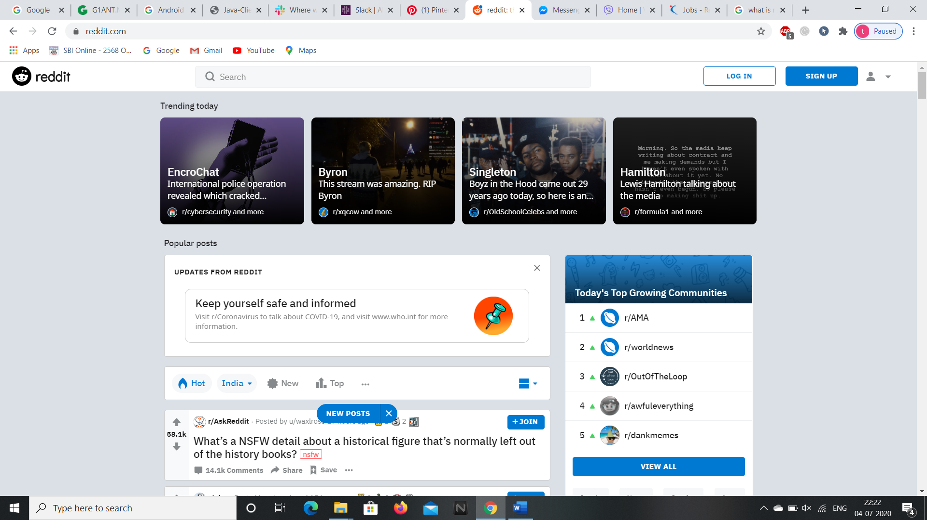

**2.Click on Sign Up button to create your account or login if your account already exists.**

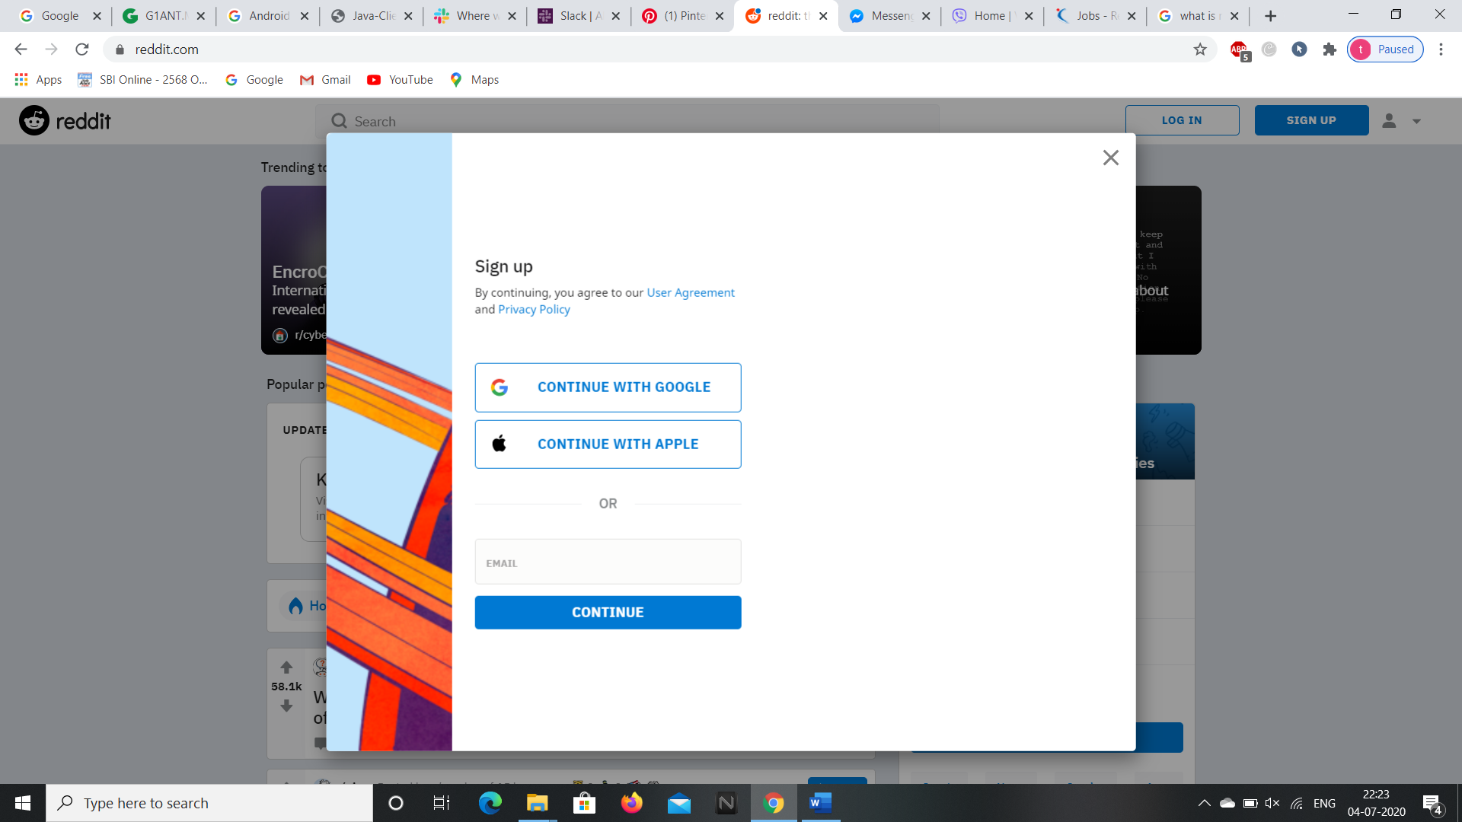

**3.After signing up we need to join 5 communities and click on the finish button.**

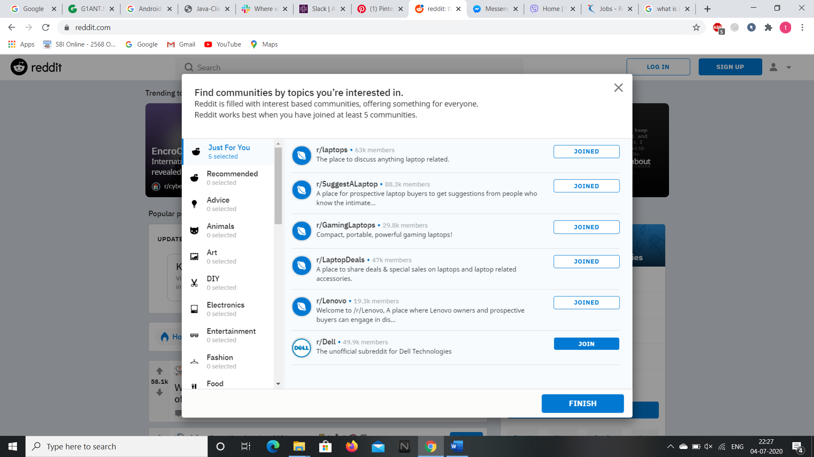

**4.Then we are redirected to the home page of reddit website.**

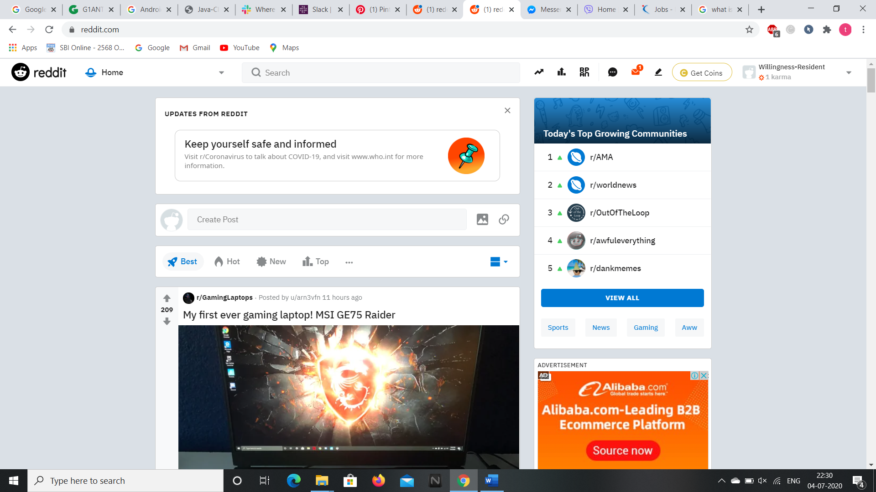

**5.We can access the popular and trending blogs by clicking on the analytics icon in the home page at top right corner.**

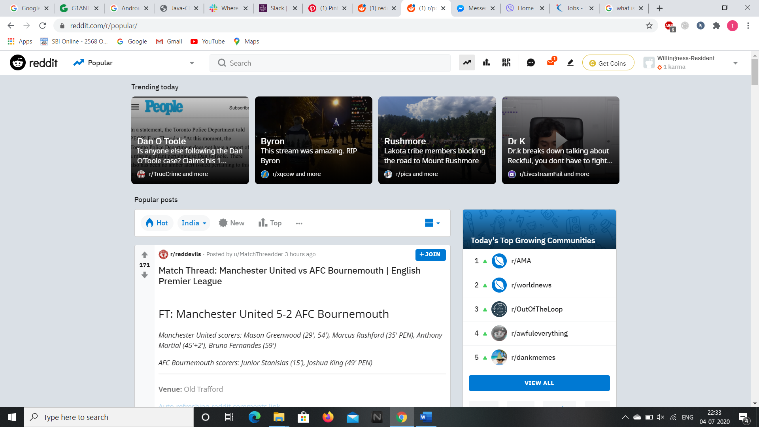

**6.We can access all the newest and top news and blogs by clicking on the icon present right side to the analytics icon.**

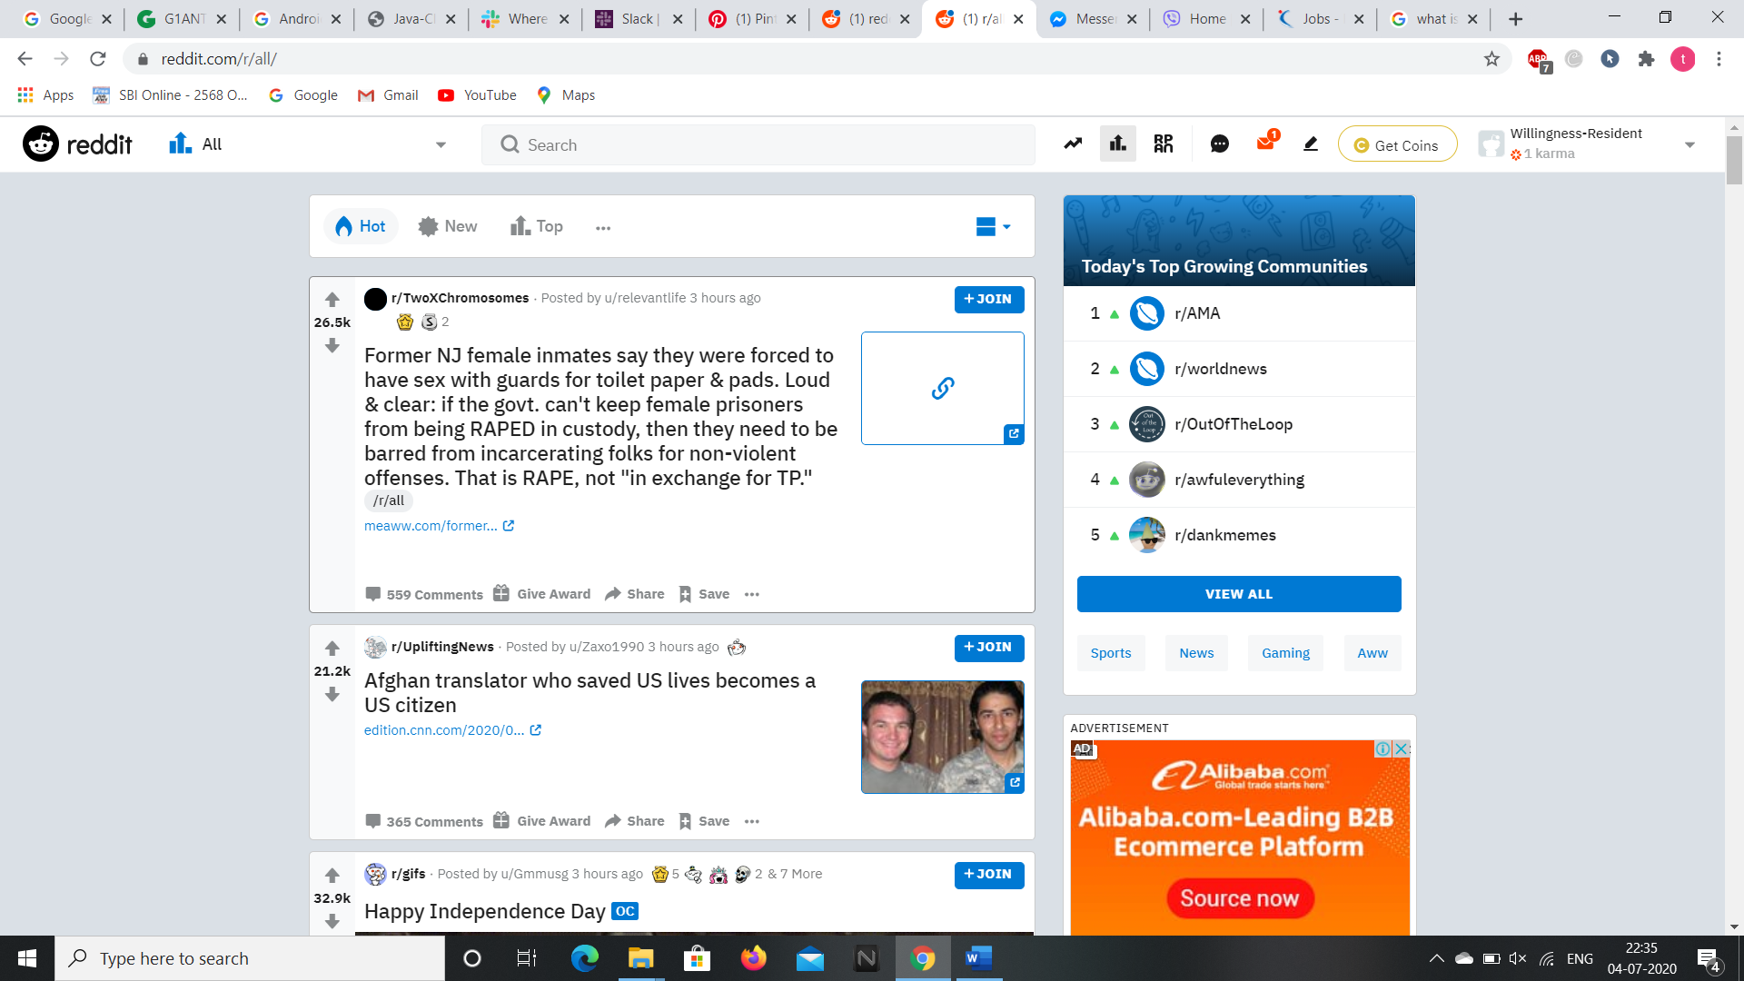

**7.To open the Reddit Public Access Network and to see the Reddit sessions click the icon present at the right side of the Top icon button.**

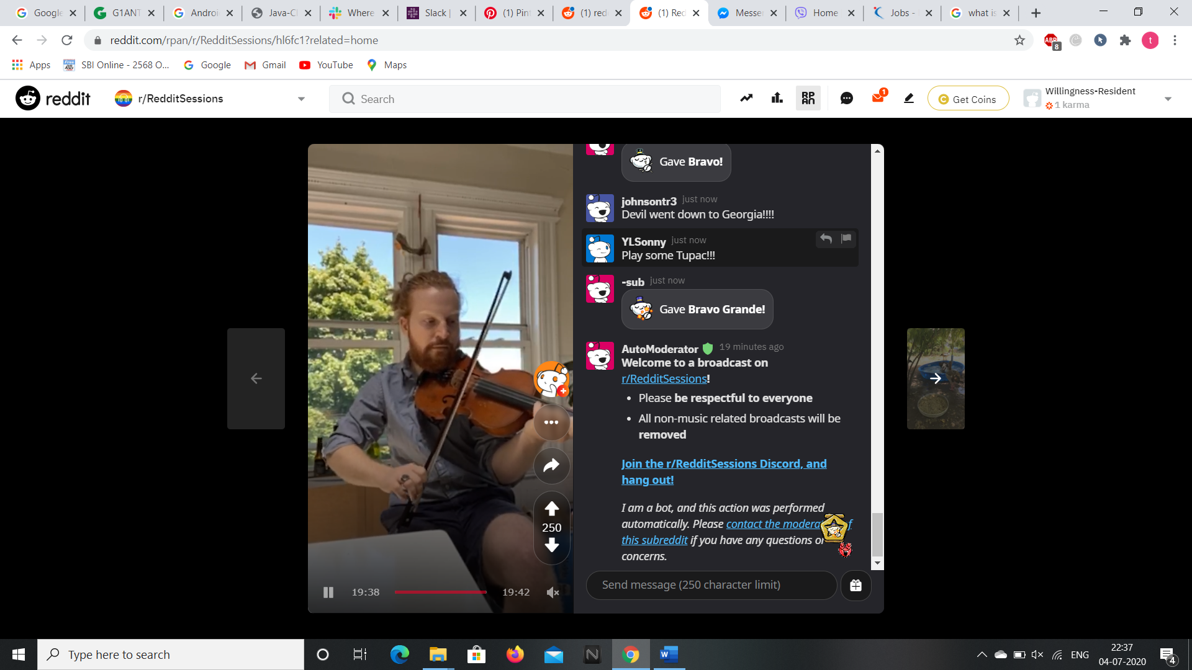

**8.To check or open your chat box or community chat box click on the chat icon button beside the Reddit Public Access Network icon.**

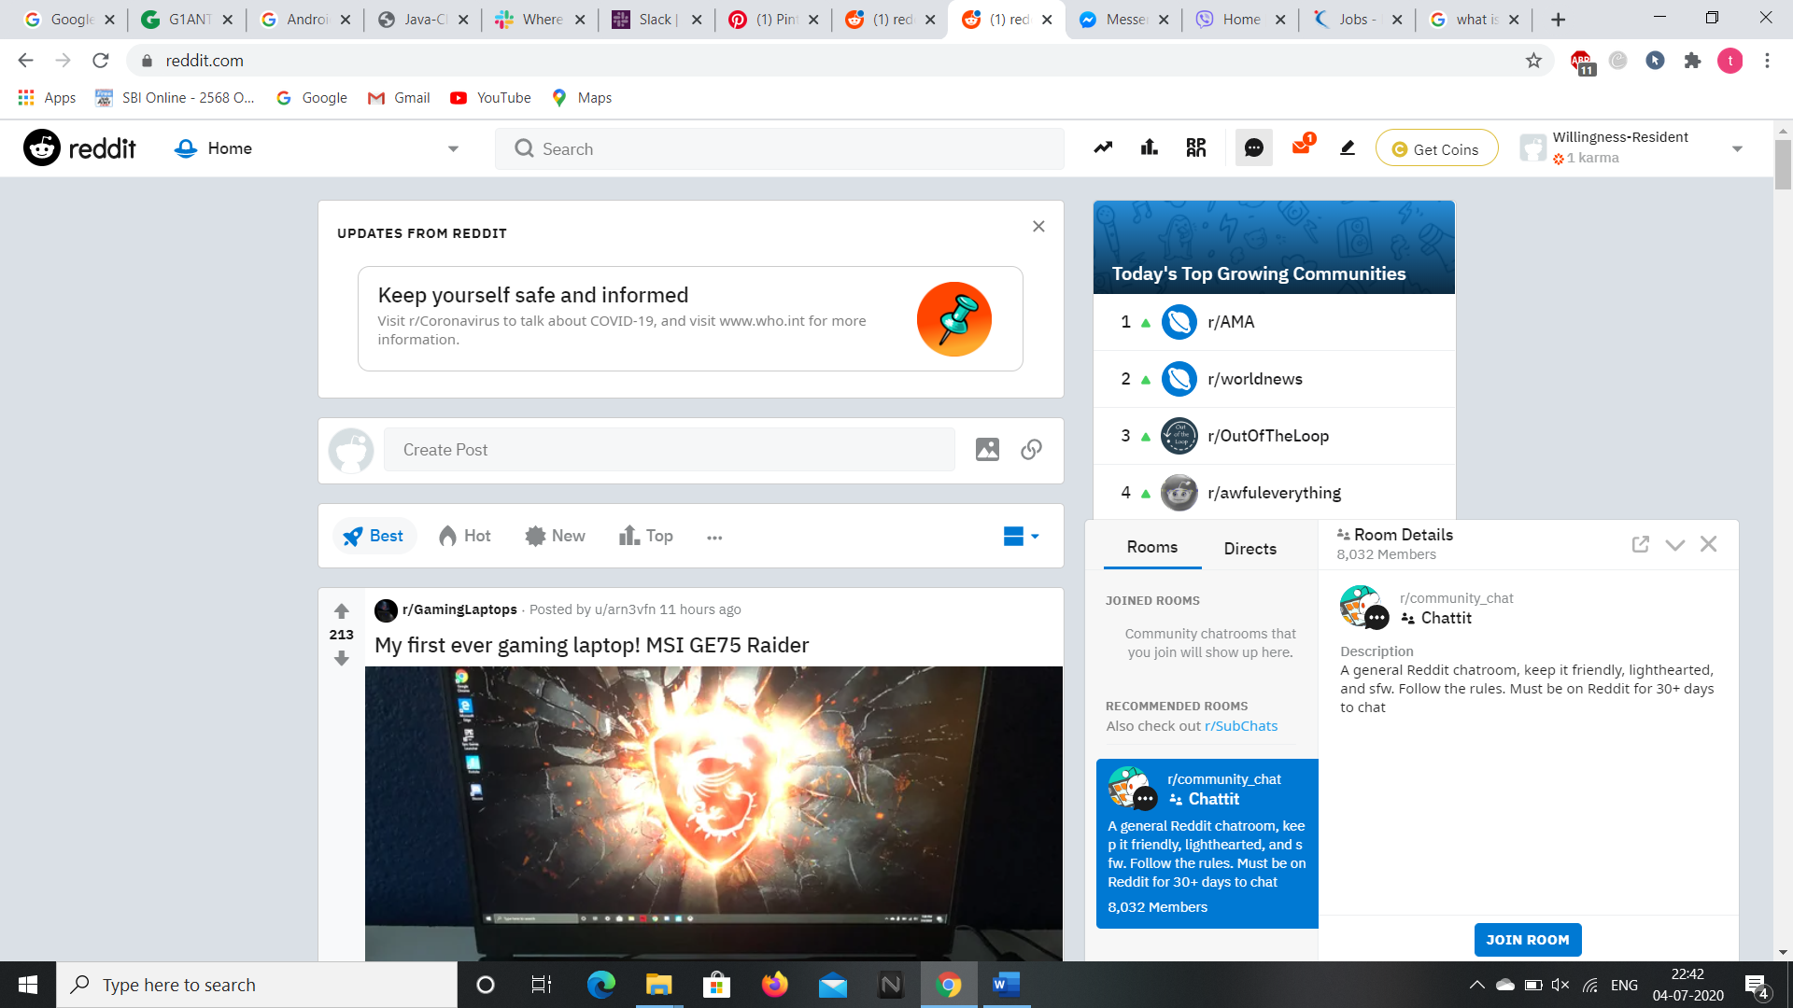

**9.To check the inbox, unread messages, messages, comment replies, post replies, sent messages and to send a private message click on the message icon present beside the chat box icon.**

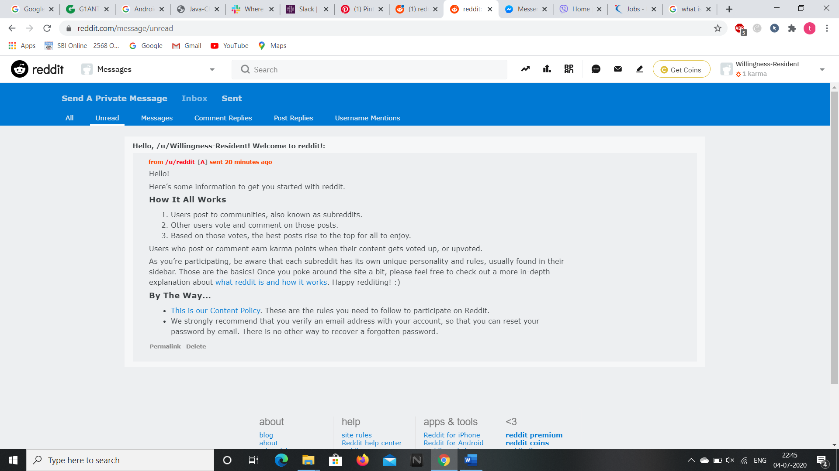

**10.To create a new post click on the edit or new post icon on the top right corner of the page.**

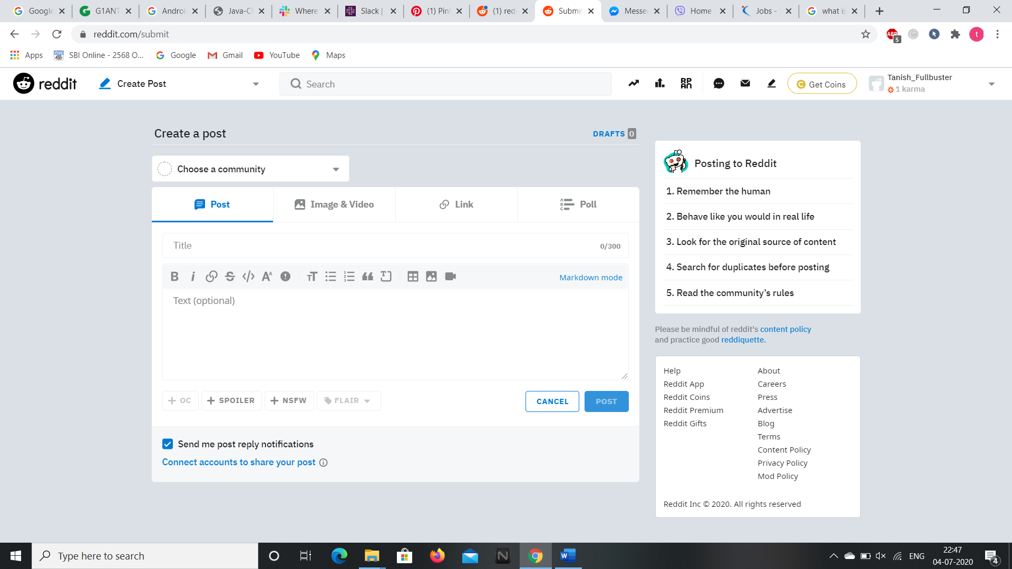

**11.To view your profile and user settings click on the drop down arrow present beside your profile name.**

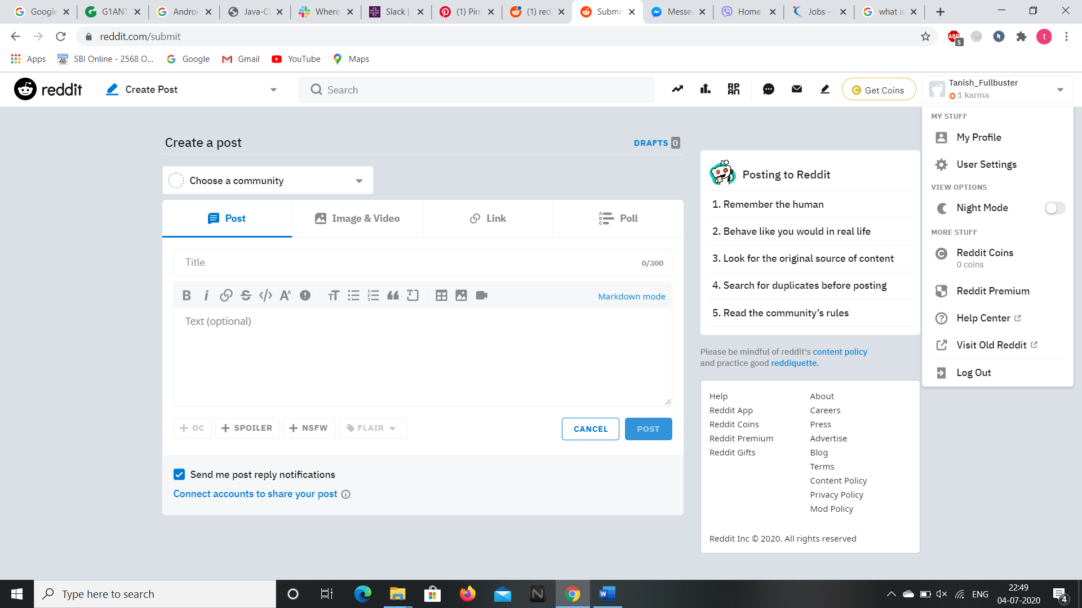

**12.In your profile you can check the overview, posts, downvoted, upvoted, awards received, awards given, hidden, comments and saved posts.**

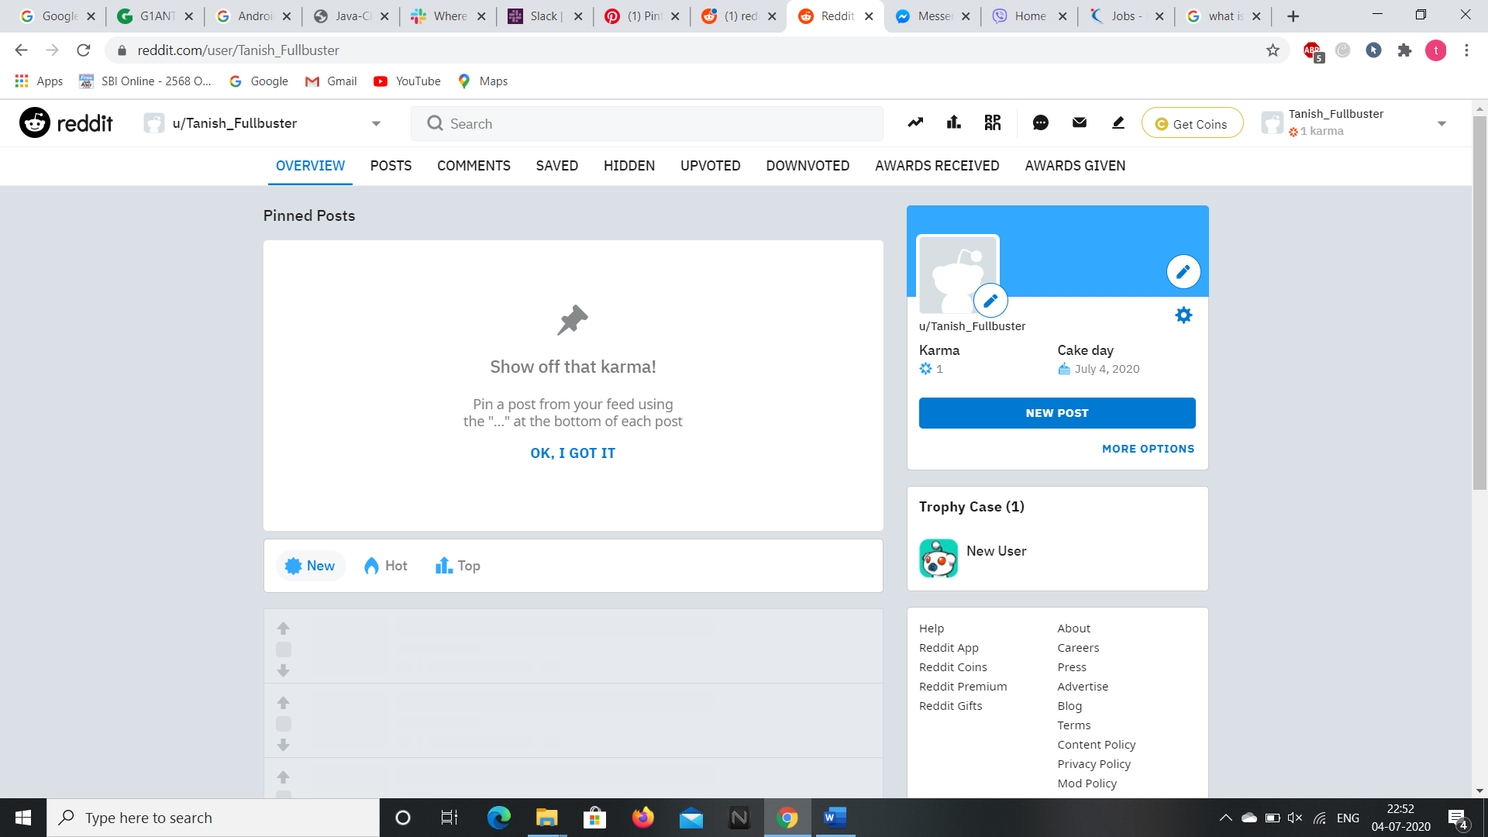

**13.In the account settings you can change your profile name, account and various privacy and secrecy settings.**

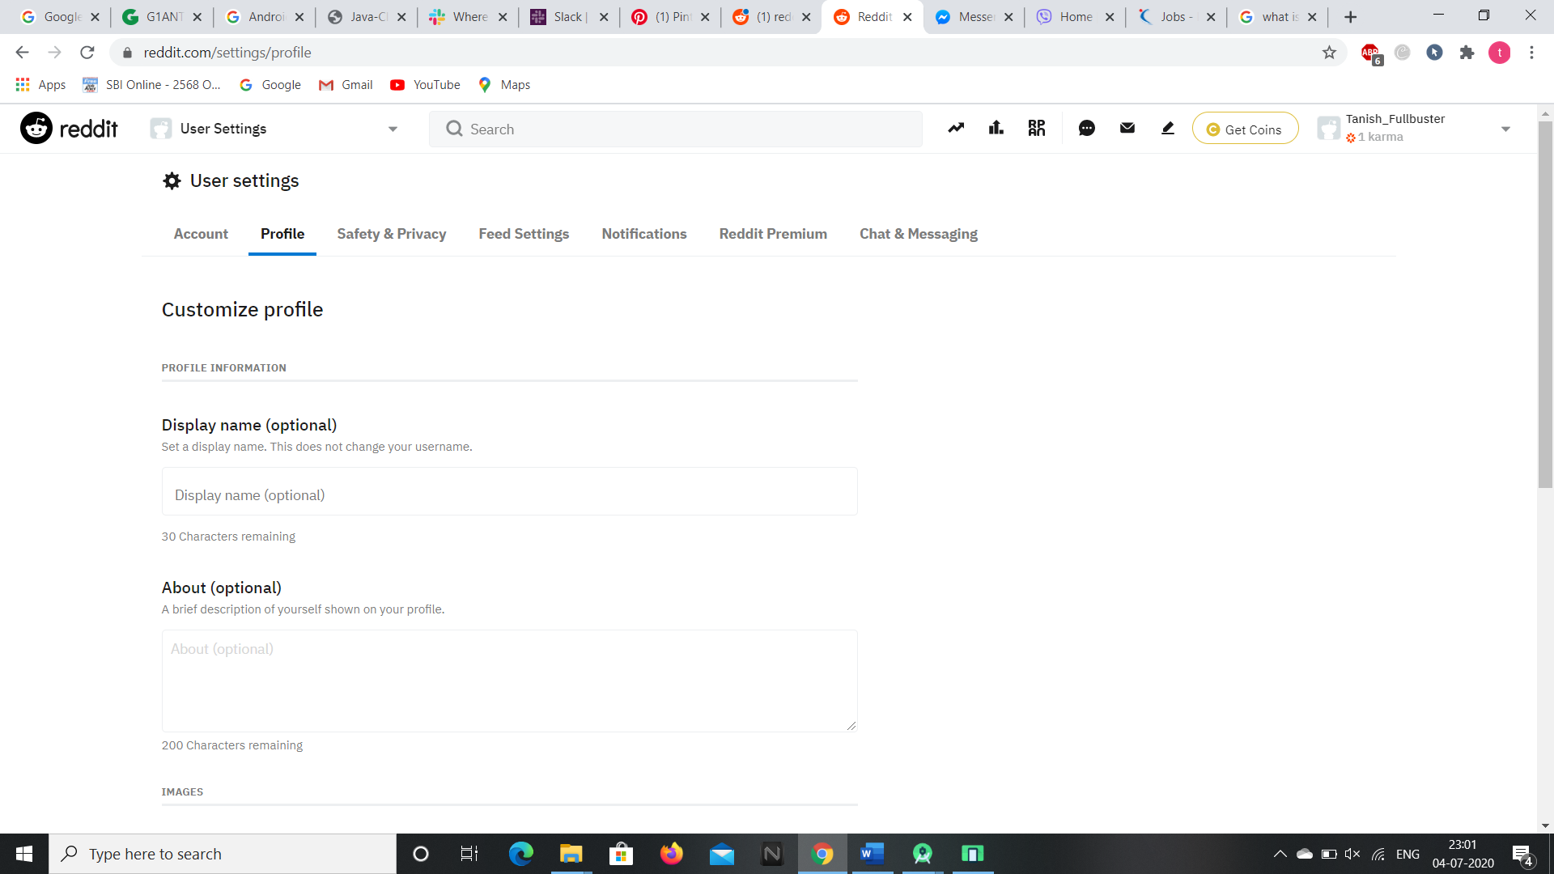

**So these are the contents present in the reddit website and we can access the webpage through selenium addon as well.**

**Now, let’s see the android application of it.**

**ANDROID APPLICATION**

**We can download the android application through “Google Play Store” and installing it in the Virtual Phone through Android Studio.**

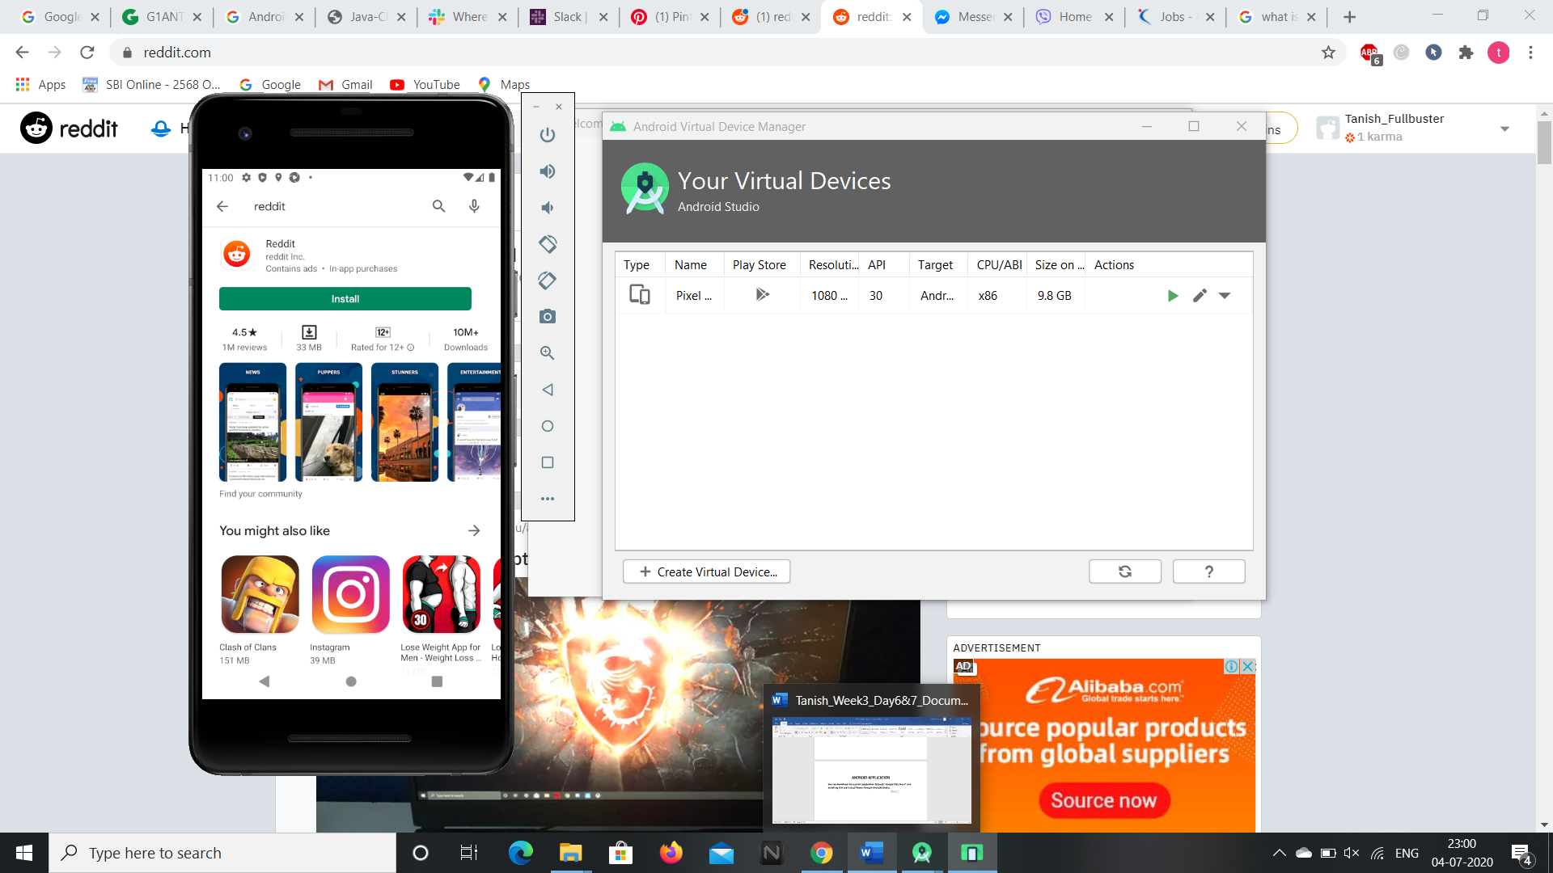

**1.After installing and opening the app, it asks to sign up or login if you have already signed up then login to reddit community.**

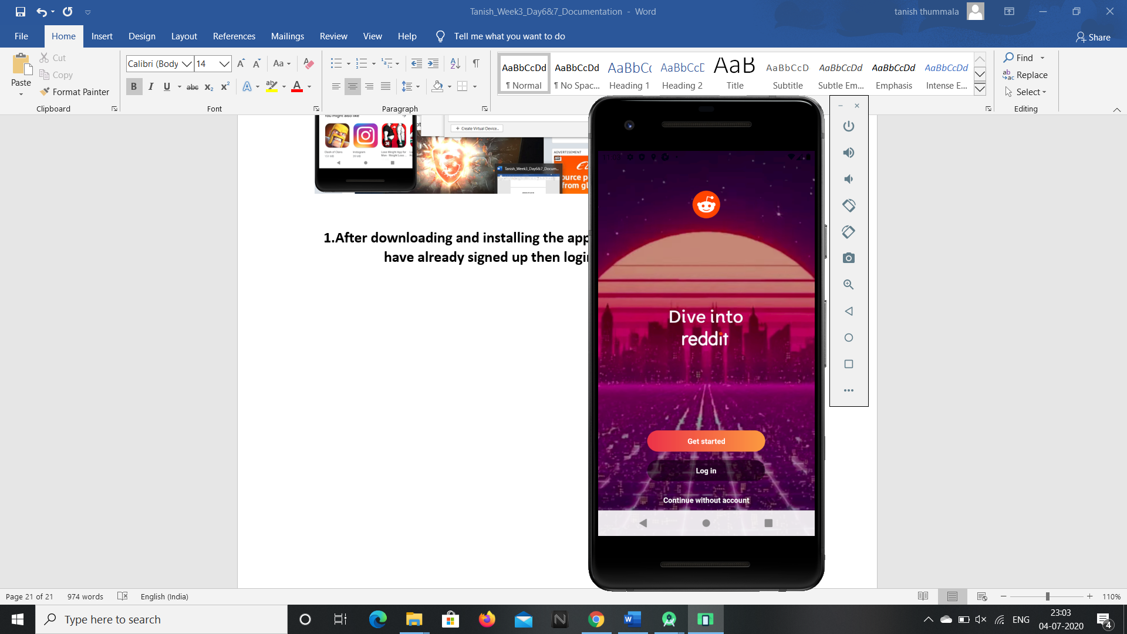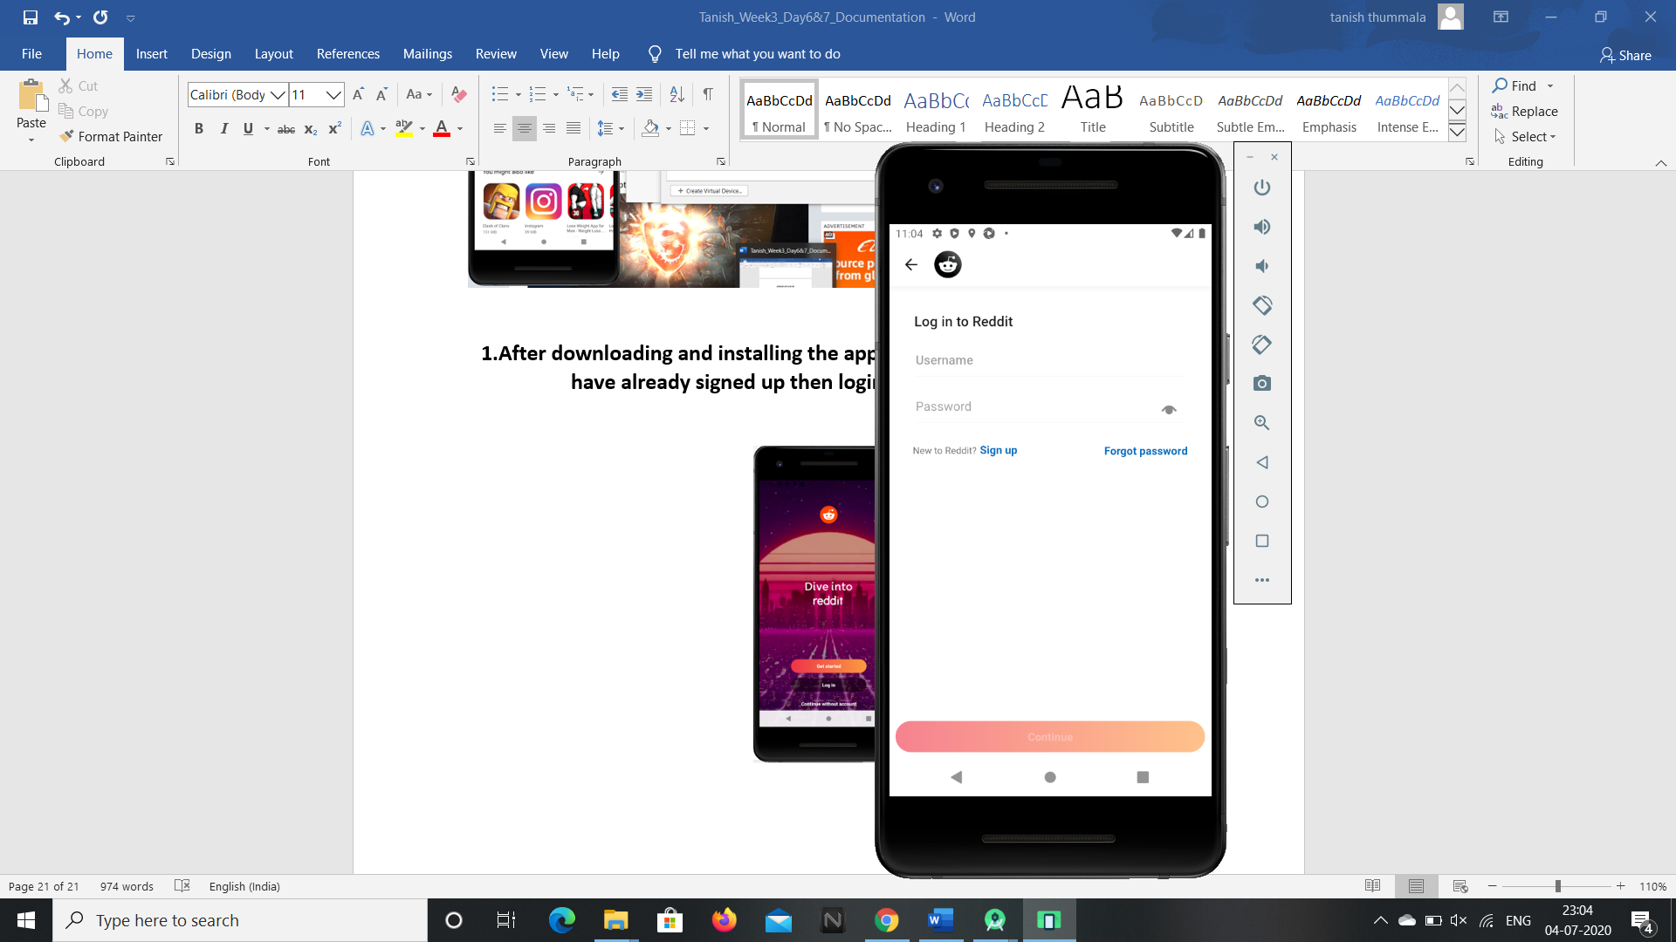

**2.Then we are redirected to the home page of the reddit community.**

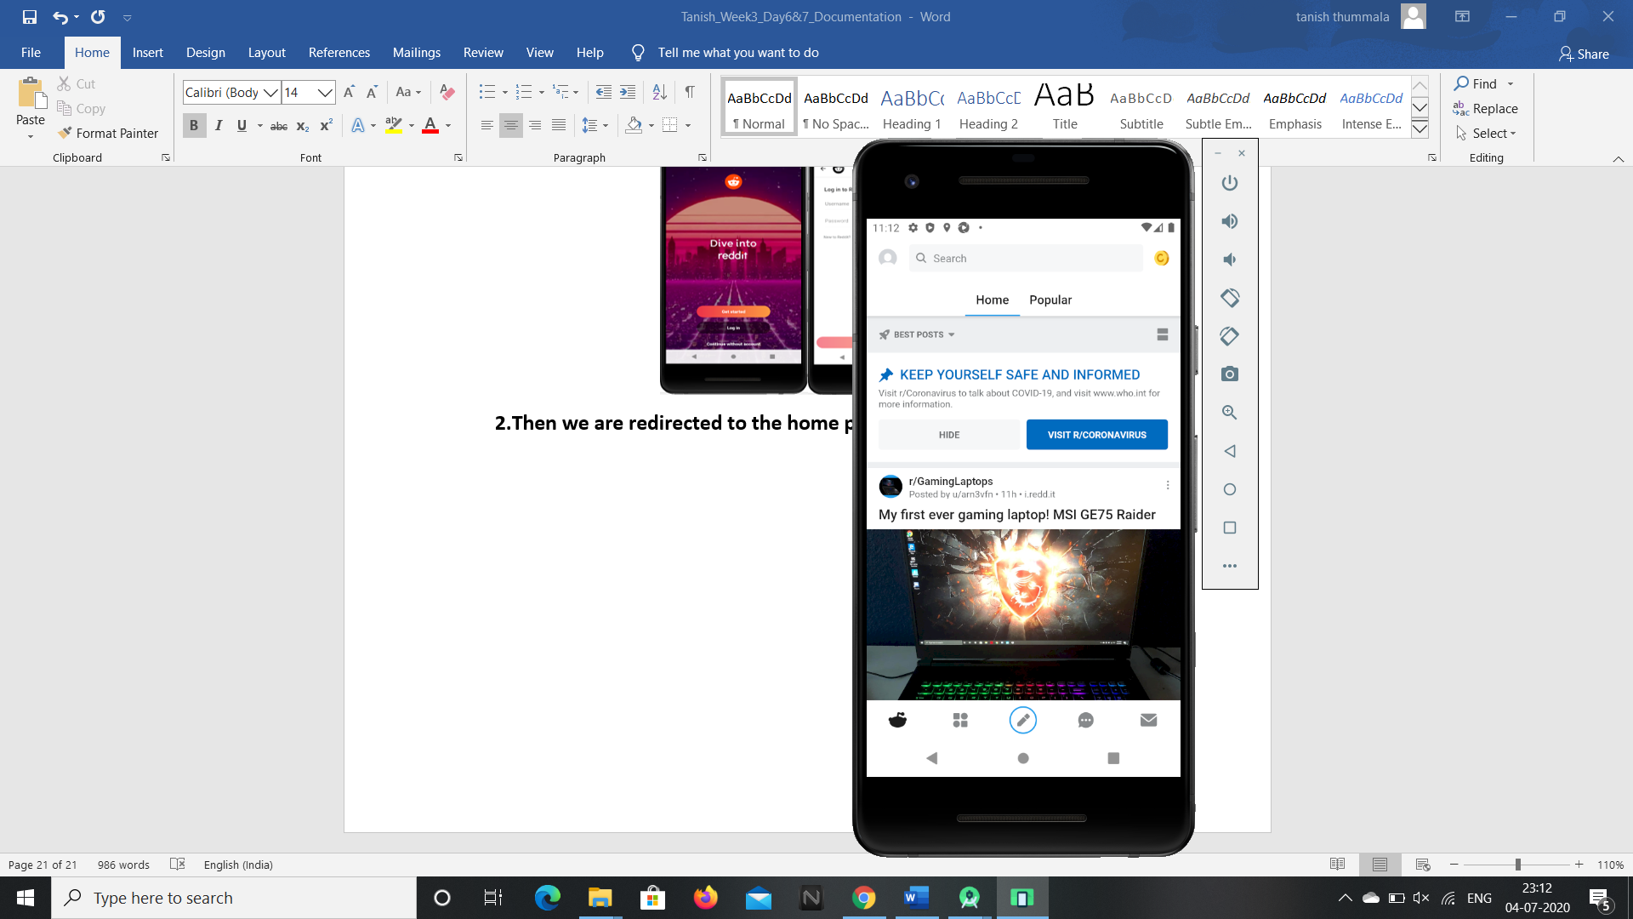

**3.To open the popular and trending news and blogs click on the popular text.**

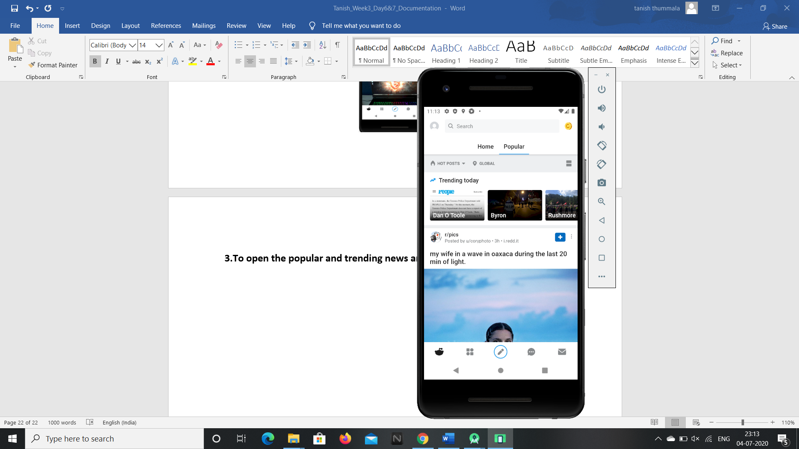

**4.To search for news or specific blogs click and type the text you want to search in the search box.**

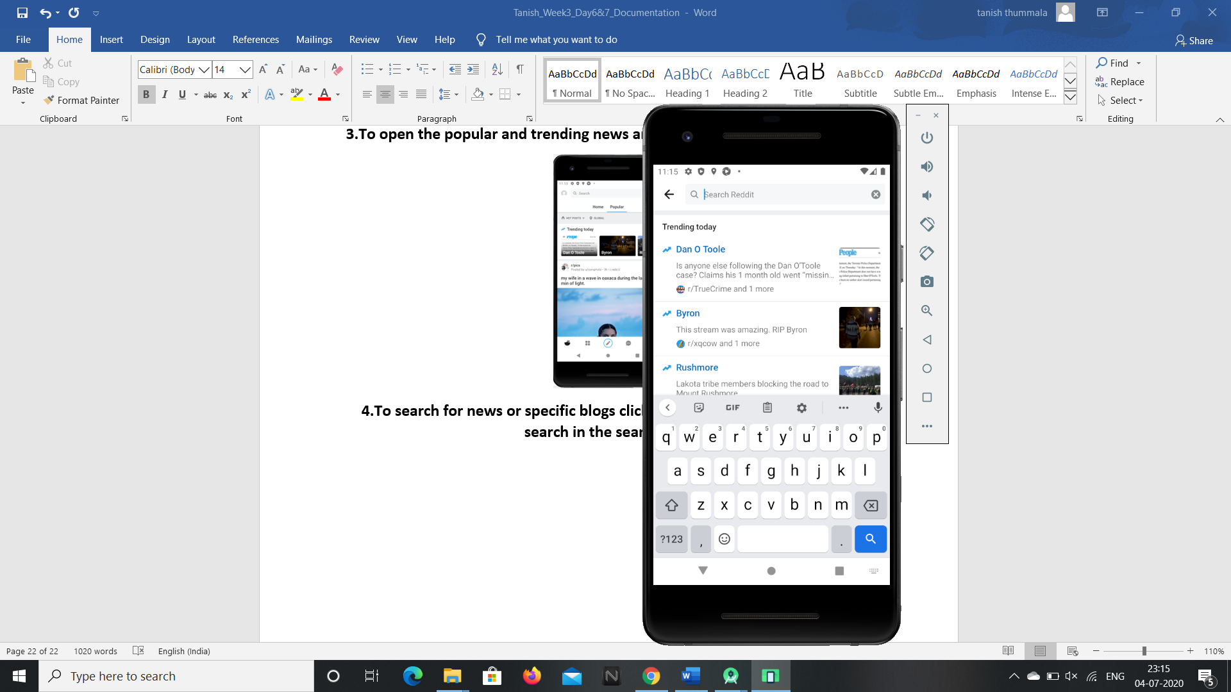

**5.To open the subscriptions and create new custom feeds click on the 4 blocks icon.**

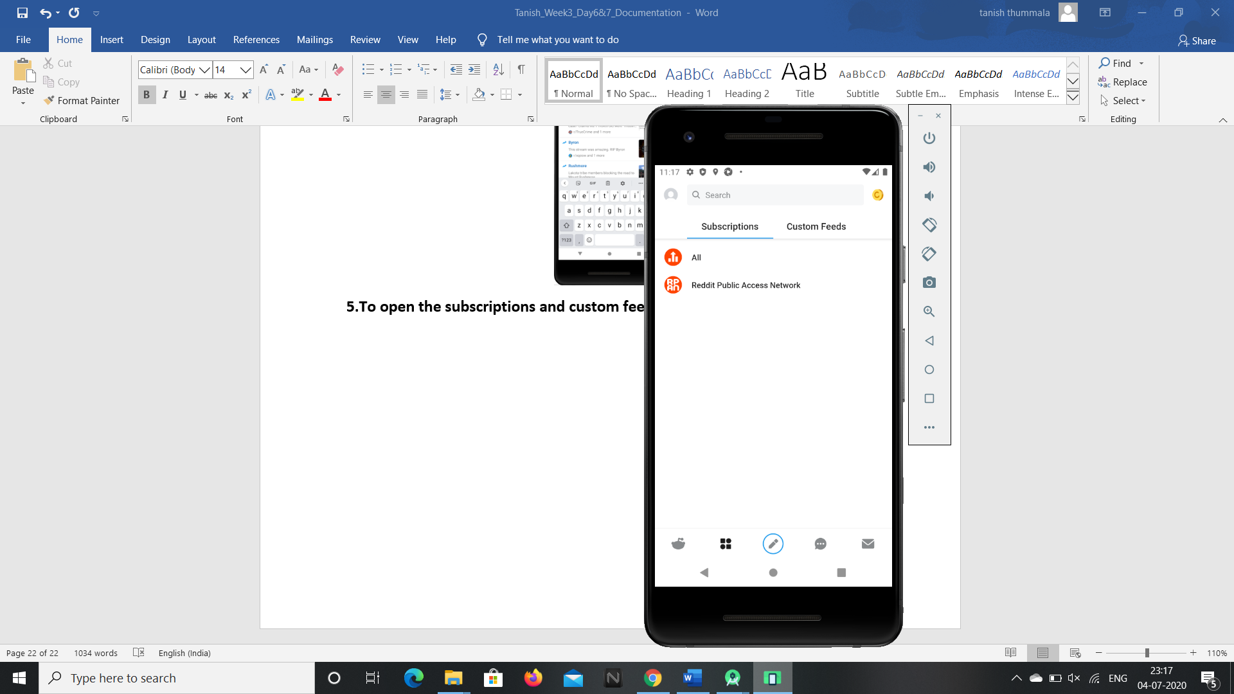 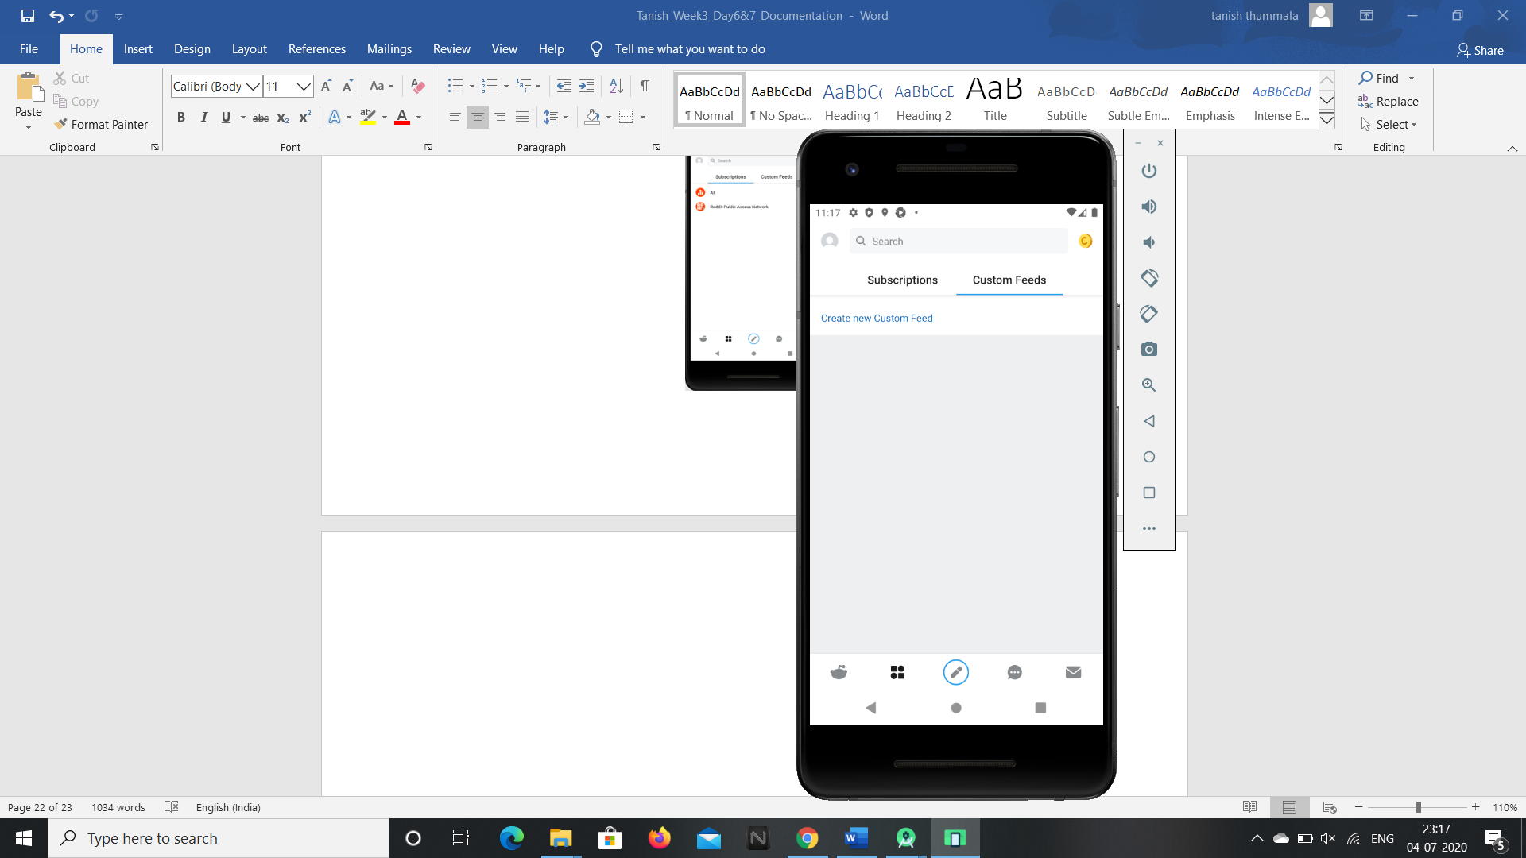

**6.To create a new post click on the edit or new post icon button in the bottom middle of the screen.**

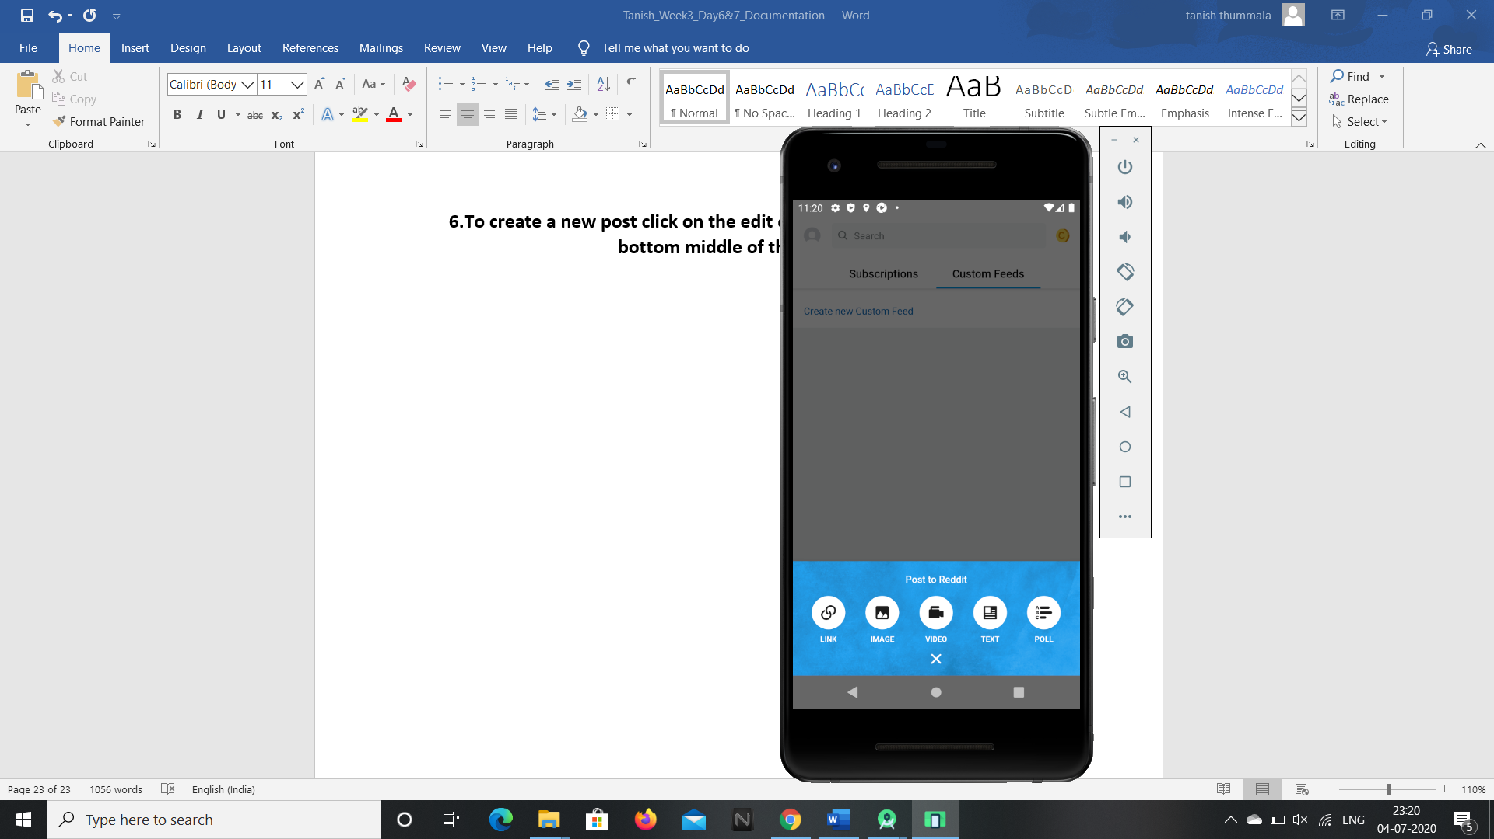

**7.To view your direct chat and room chats click on the chat box on the bottom middle, right beside new post icon button.**

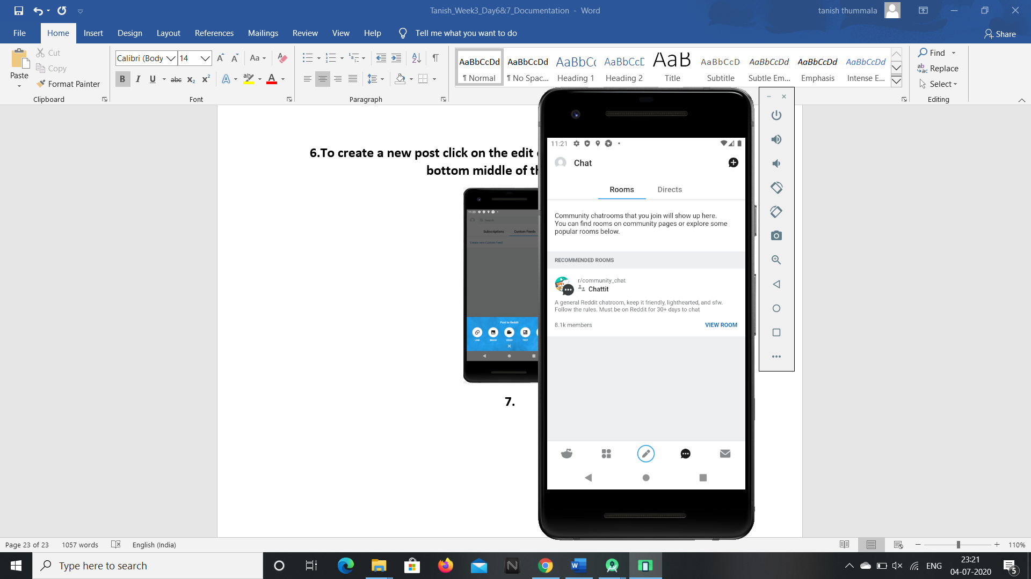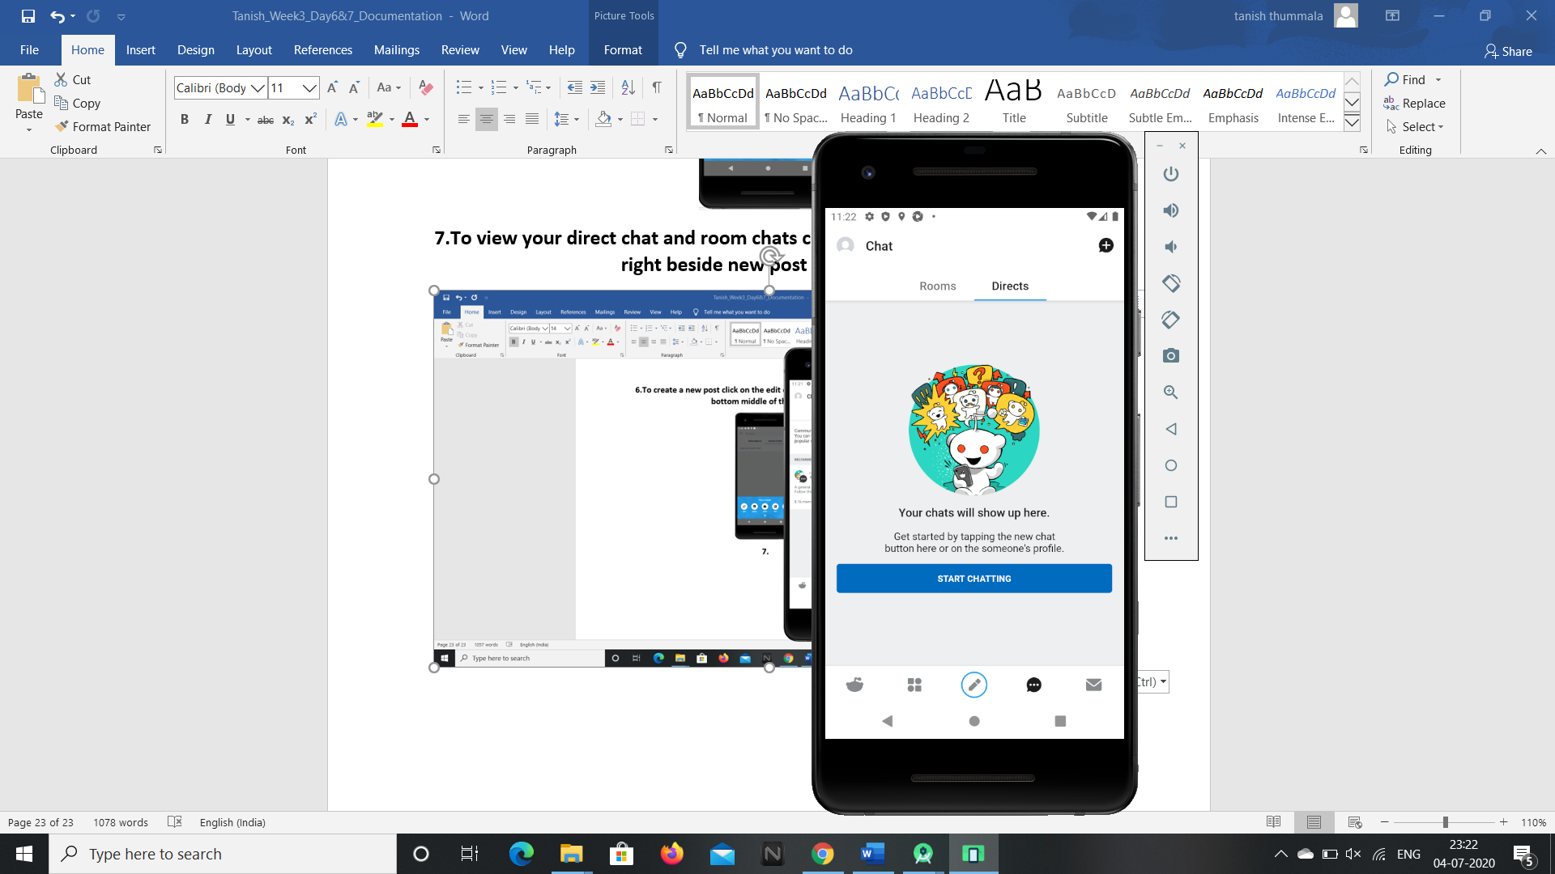

**8.To view notifications, messages and mod mail click on the message icon button at the bottom right corner.**

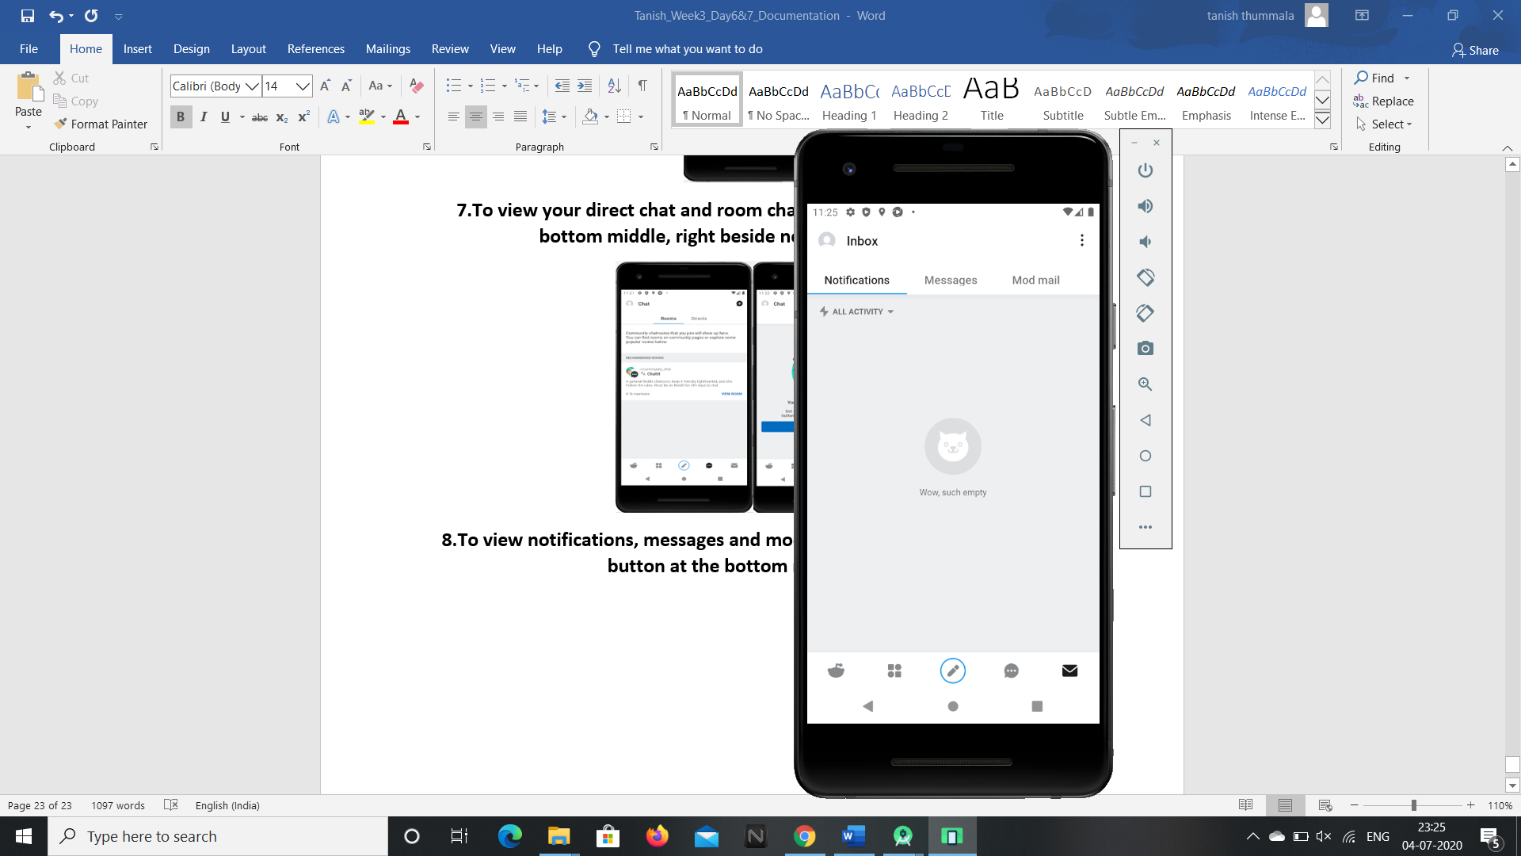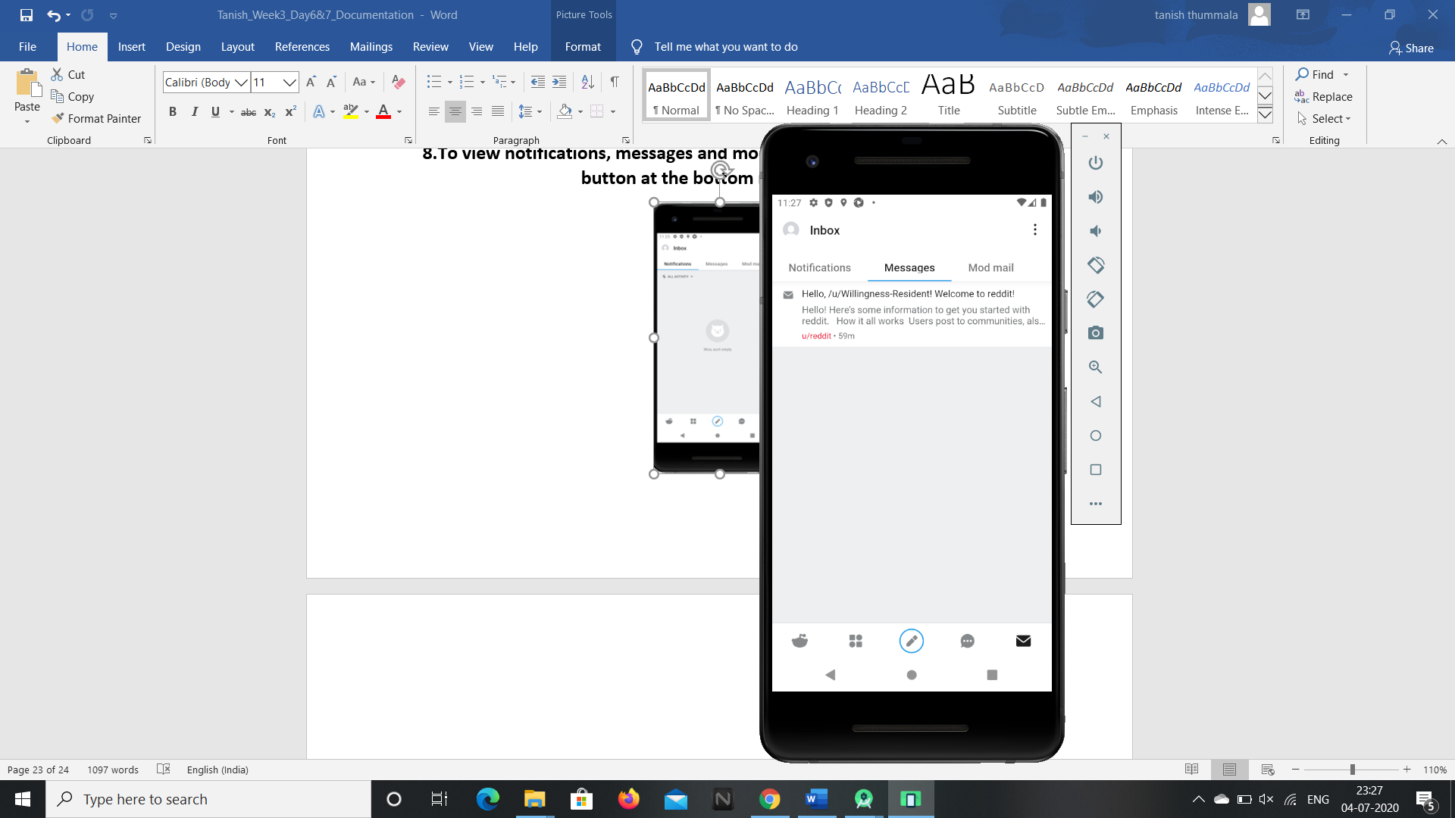 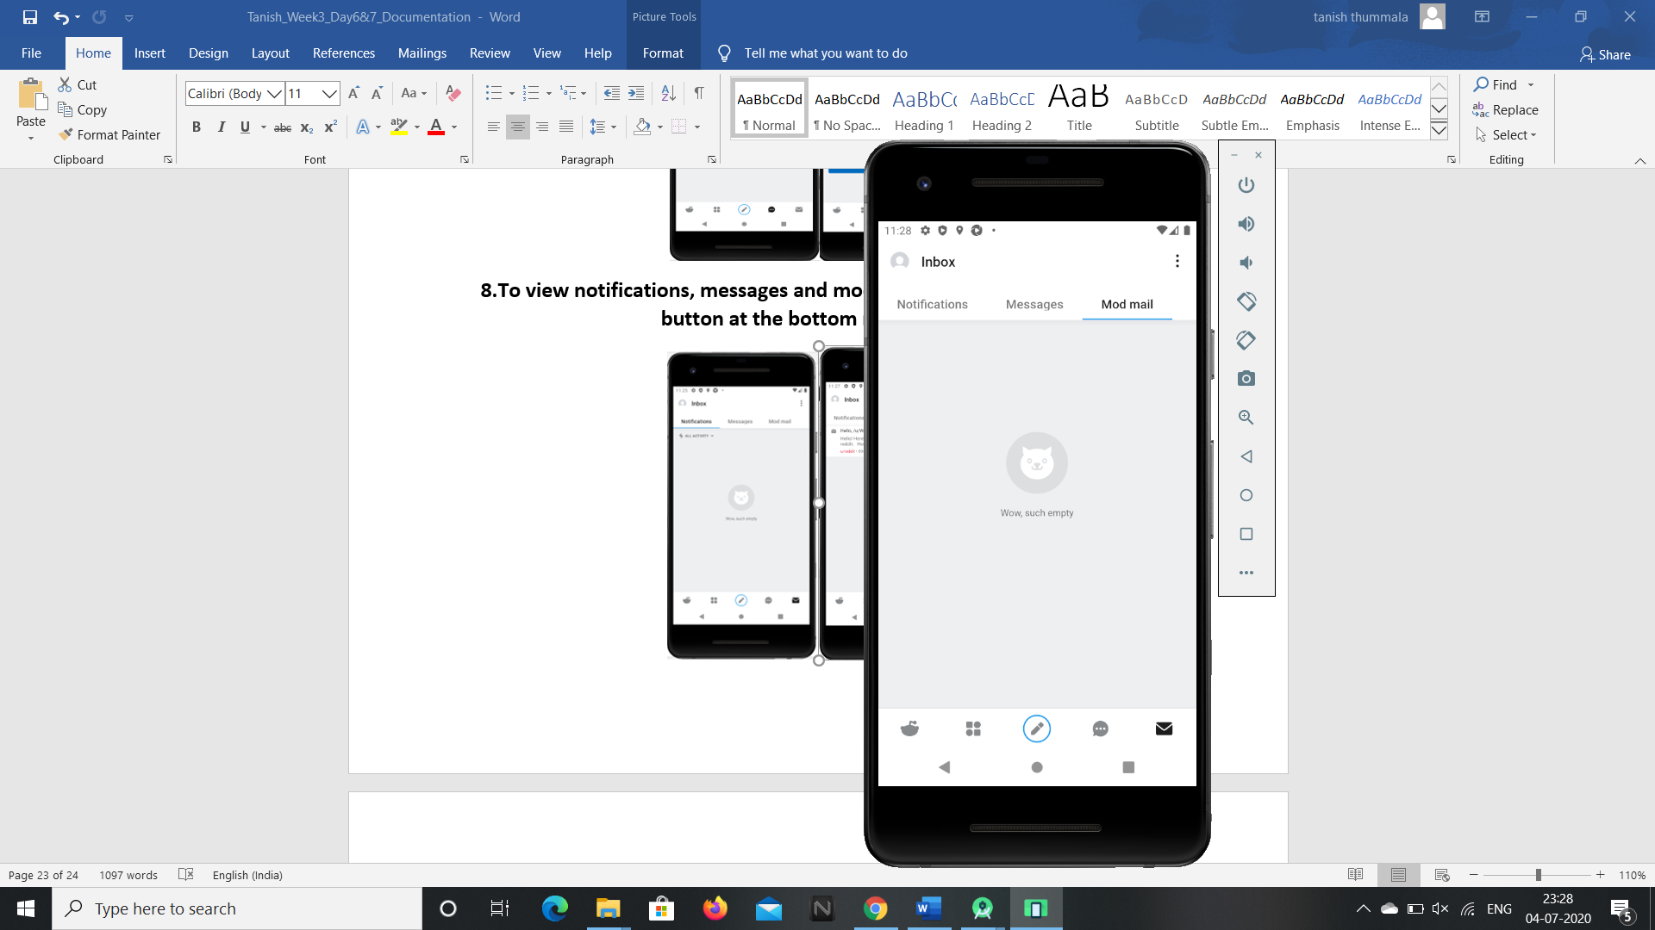

**9.To view the profile settings click on the profile icon in the left corner of the screen.**

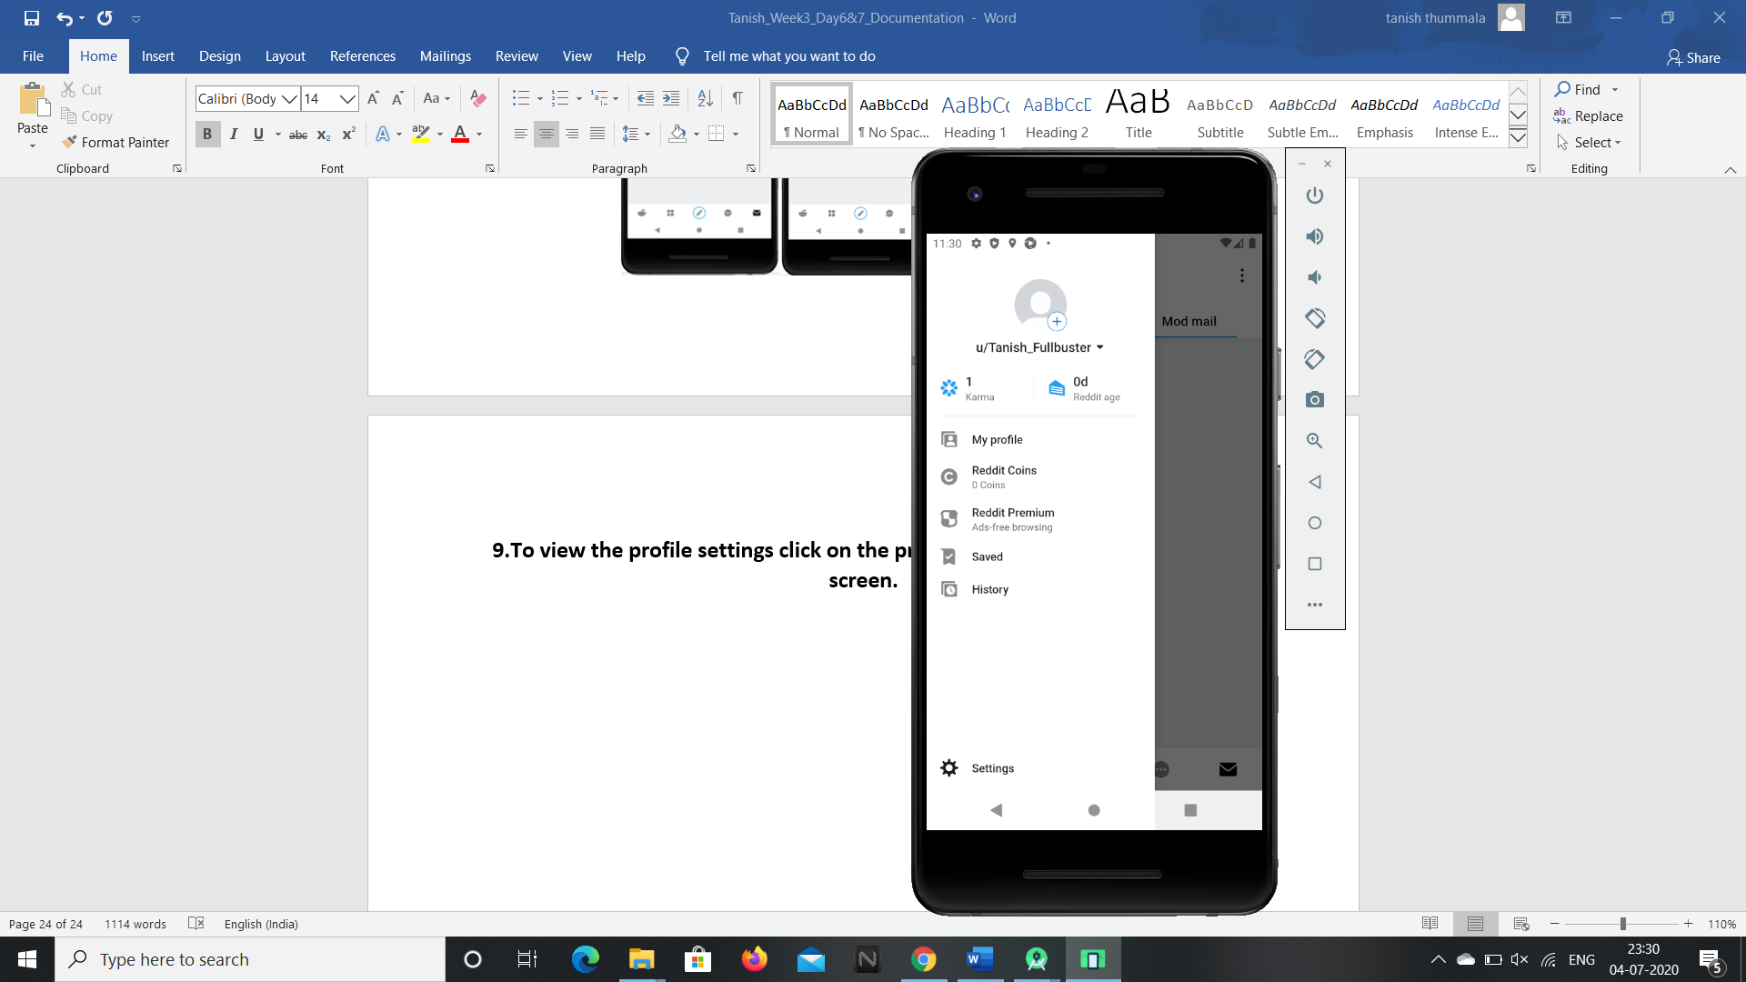

**So these are the features present in the reddit android application and these**

**can be accessed by G1ANT Robot through Appium addon.**